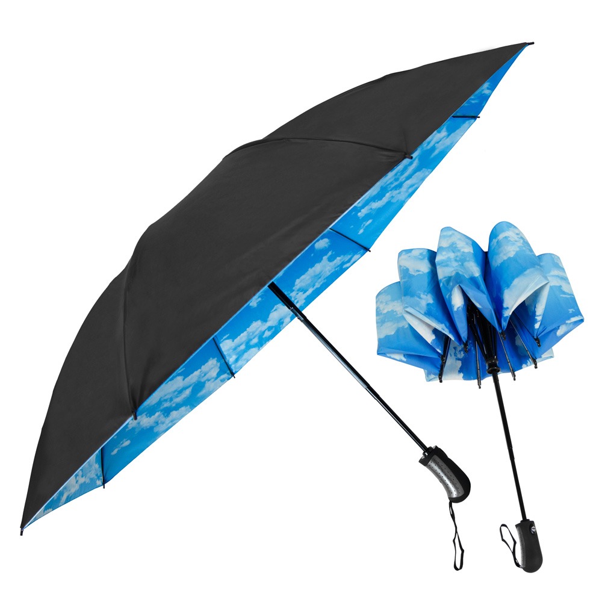
SB-4676

The SkyView Inverted Folding Umbrella

Designed to not only protect you from the rain, but also from getting wet when closing a rain-soaked umbrella, the auto-open/auto-close Sky View Inverted Folding Umbrella features an eye-catching 46" arc (black upper canopy/vibrant blue skies underneath) and sturdy construction. The Sky View closes in reverse fashion, keeping the wet side of the umbrella contained and away from you, making it easy to open and close anywhere, and keeping you dry from start to finish. Its compact folded length of only 13" means you can store it almost anywhere.

Arc Size: 46” Number Of Panels: 8

Diameter: 41” Length When Closed: 13”

Opening: Automatic Closing: Automatic Imprint Area: 6”H x 7”W

Shipping weight 36 pieces: 32 lbs. Box Dimensions: 14” x 13” x 13”


